5 Analyzing structured data

This chapter covers
- Translating questions to queries
- Building natural language interfaces
- Analyzing data tables
- Analyzing graph data
Please ignore grammar errors and typos. What you see is a raw manuscript; it has not been copyedited.
A significant percentage of the world’s information is stored as structured data. Structured data generally means data stored in a standardized format. For example, data tables (e.g., think of the data you would find in an Excel spreadsheet) or data describing entities and their relationships as graphs (e.g., think of a data set describing a social network) are popular types of structured data.
Tools for processing structured data have been available for many decades. After all, structured data has a standardized format, optimized for making it easy to process by computers. So why do we need large language models for that? The problem with existing tools for processing structured data is their interface. Typically, each tool (or, at the very least, each category of tools for specific types of structured data) supports its own formal query language. Using this language, users can often perform a wide range of analysis operations on structured data. But learning such query languages takes time! Wouldn’t it be nice if all those systems could be queried by a single language, ideally in natural language (e.g., plain English)?
This is where language models come into play. Large language models are able to translate questions in natural language into a wide range of formal languages. So, we can use them as a universal interface to various data analysis tools, supporting a wide range of structured data types. In this chapter, we will build natural language query interfaces for different types of structured data. Such interfaces enable us (or others) to analyze data by simply typing questions in plain English. The system then translates our questions into formal queries, executes them, and presents us with a result.

5.1 Overview

Figure 5.1 A natural language query interface translates questions in natural language into formal queries, taking into account the data structure. Formal queries are then processed on data by a specialized tool, generating a query result.
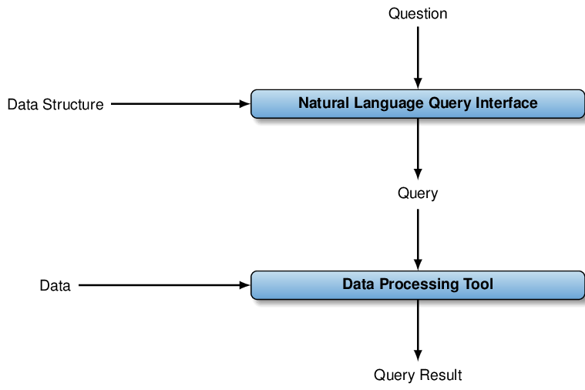
Up - understood
We will be creating several natural language query interfaces in this chapter. In general, a natural language query interface answers questions about data, formulated in natural language. This chapter considers different types of structured data. First, we will create a natural language interface that answers questions about tabular data. After that, we will create one that answers questions about large data graphs.
The principle is the same in both cases. We assume that data are stored in a specialized tool for data processing. For instance, for data tables, we will assume a relational database management system. For graph data, we will assume a system for managing graph data. Then, we use the large language model to translate questions in natural language into the query language supported by the specific tool. For instance, for a relational database management system, this is typically the structured query language (SQL). Graph database management systems support a variety of graph data-specific query languages. We will use the Cypher query language (a language describing analysis operations on graph data). We will discuss both languages in more detail in the following sections.
To translate questions into formal queries, the language model needs access to the question (of course), some information on the target language (e.g., do we want to write SQL or Cypher queries?), and some information about the structure of the data we are trying to query. For instance, the structure of tabular data is characterized by the names of tables, the headers of the columns that appear in those tables (hopefully providing some hints on the semantics of data stored within them), as well as the data types of each column (are we storing integer values or strings?), among other things. By providing the language model with all of the aforementioned pieces of information, including them in the prompt, the model should be able to produce a formal query that captures the semantics of our question.
We can process that query using the specialized tool to produce a query result. Assuming that the query translation was correct, this result represents an answer to the original question. Figure 5.1 illustrates the whole process.

Why do we need external tools?
We have seen that language models can solve a variety of tasks. So why not simply use language models to analyze structured data directly? Why do we rely on external tools to do so and use the language model merely as a translator? Above all, the reason is efficiency. Using large language models is expensive and, at least for large data sets, the size of the data could easily exceed the maximal input size of the language model. Hence, relying on existing tools that can deal with large structured data sets seems more promising.
Any comments on section 5.1 Overview?

Up – Understood.

5.2 Setting up an SQLite database
We will be creating a natural language query interface to access data tables, stored in SQLite. SQLite is a popular relational database management system, i.e., a tool for processing data tables. As a first step, we should make sure that SQLite is installed. We will be using SQLite in version 3 in this section. You can check whether SQLite 3 is installed by typing
sqlite3 --version
copy
in your terminal. If you receive a message like the one below, no further installation is necessary:
3.33.0 2020-08-14 13:23:32 fca8dc8b578f215a969cd899336378966156154710873e68b3d9ac5881b0alt2
copy
If you see an error message, go to https://www.sqlite.org/download.html instead. Select the version that is consistent with your operating system, download all relevant files, and follow the given instructions to install SQLite. In case of problems, visit https://www.tutorialspoint.com/sqlite/sqlite_installation.htm. This URL contains a detailed tutorial describing how to install and set up SQLite on different platforms. Afterwards, run the command above to ensure that SQLite is installed properly.
Next, we want to create a relational database inside of SQLite. A relational database is essentially a collection of data tables. You can think of each data table as a simple spreadsheet. We have named table columns, associated with a data type, and (possibly many) table rows that contain a value for each of the columns. For instance, have a look at Table 5.1. This table contains information on video games and each row represents one game. The table has four columns, namely “Name”, “Platform”, “Year”, and “Genre”. Three of the columns (Name, Platform, and Genre) contain strings (i.e., text). Column “Year” contains numbers (representing the year in which a game was published).

Table 5.1 Sample of data table. Each table row describes one video game.
Wii Sports | Wii | 2006 | Sports
Super Mario Bros. | NES | 1985 | Platform
Mario Kart Wii | Wii | 2008 | Racing
Wii Sports Resort | Wii | 2009 | Sports
Pokemon Red/Pokemon Blue | GB | 1996 | Role-Playing
Up – understood.
Table 5.1 shows a small sample of a data set you find on the course Web site (look for item “Games” in the section associated with this chapter on the book Website). We will use that data set in the following sections to create a natural language query interface, enabling users to analyze it with natural language commands. But first, we need to load that data into the SQLite database system.
Let’s start the SQLite command line interface. Enter the following command in the terminal and hit enter:
sqlite3 games.db
copy
This command creates a new database, stored in the file “games.db” on the hard disk. At the same time, it opens up the SQLite command line interface. Now, we can instruct the SQLite tool to load the data set we will be using in the following sections. First of all, we have to tell SQLite a little bit about the structure of the data we want to load. We want to load an extended version of the table shown in Table 5.1, containing additional columns. Run the following command to describe the structure of the data we are about to load:
create table games(rank int, name text, platform text,
year int, genre text, publisher text, americasales numeric,
eusales numeric, japansales numeric, othersales numeric,
globalsales numeric);
copy
This command describes the structure of a single table, an extended version of the one shown in Table 5.1. The name of the table is “games” (since it will store information about video games) and, within parenthesis, we specify the full list of columns of that table (separated by commas). Each column is defined by the column name (e.g., “rank”, “name”, or “genre”), followed by the column type. E.g., “int” means the column stores integer numbers, whereas “text” means the column stores text data. All table rows must provide values for each column of the appropriate data type.
After defining the table structure, we can now load data into the table. We will load data from the .csv file on the book Web site (item “Games” in the section associated with Chapter 7). First, download the file from the book Web site if you haven’t already. We will assume that the file is stored in the folder “/Downloads/videogames.csv” for the following commands. Simply replace that path with the file path on your system. We load data using the following command (still in the SQLite interface):
.mode csv
.import /Downloads/videogames.csv games
copy
The first command prepares SQLite to load data from a .csv file (which applies to the file we want to load). The next command imports data. The first parameter is the path to the file we want to load data from. The second parameter is the name of the data tables we want to load the file into. In this case, we reference the table whose structure we defined before (named “games”). To test whether the data was loaded successfully (that should be the case if you don’t see an error message), run the following command in SQLite:
select count(*) from games;
copy
You should see the result “16599” if all data was loaded. If you see a lower number, check for error messages in
I see 33198
the output of SQLite. You can quit the SQLite console via the command “.quit” (don’t forget to prefix your command with a dot to make it work). For the following sections, we will assume that the data has been loaded and is stored in an SQLite file called “games.db”.
Any comments on section 5.2 Setting up an SQLite database?

? – instructions easy follow but result was different should I be concerned.

5.3 The SQL query language
SQLite understands queries, formulated in the structured query language (SQL). A full introduction to SQL is far beyond the scope of this book. Have a look at the Web site www.databaselecture.com to get an introduction by this book’s author. Next, we discuss a few SQL basics that will be helpful to implement our natural language query interface.
SQL queries are used to analyze data tables. Query results may be derived from a single table or by combining data from multiple tables. In our example database, created in the last section, we only have one single table. Using SQL queries, we can for instance count rows with certain properties (e.g., all games by the same publisher), filter data (e.g., only show games that were released in 2017), or perform various aggregate operations (e.g., for each publisher, show the number of games for the Nintendo that sold at least 1 million copies).
For the purpose of our natural language query interface, an SQL query generally describes a new data table to generate (using data that is already available in the database). In the simplest case, an SQL query has the following structure:
SELECT [Columns or Aggregates]
FROM [List of tables]
WHERE [List of conditions]
copy
The FROM clause describes the source data used for analysis. In the simplest case, the FROM clause contains a list of table names, separated by commas. In this case, we only have a single table to process (for advanced queries, we still may have the same table name appear multiple times in the FROM clause, creating different copies of the same table). Most queries we will encounter in the following sections will likely contain one single entry in the FROM clause, the table “games” (which we created in the previous section).
The WHERE clause defines predicates on the tables that appear in the FROM clause. For instance, it might contain a condition, restricting the scope to games from a certain publisher. The WHERE clause can contain simple conditions (i.e., conditions that can be expressed by an equality or inequality on a table column), as well as complex conditions (connecting multiple simple conditions by AND or OR operators). Those conditions are used to filter rows from the tables in the FROM clause. Rows that do not satisfy the condition in the WHERE clause are discarded and do not influence the query result.
Finally, we specify the columns of the desired result table in the SELECT clause. More precisely, we specify a list of column definitions, separated by commas. Columns may be defined simply by a column name (one that appears in one of the tables in the FROM clause) or a more complex expression, e.g., an arithmetic expression connecting multiple columns or an aggregate such as “count(*)” (the latter aggregate counts the number of columns). The query result contains a table with the specified columns, filling them with content in accordance with the column definition.
For instance, let’s say we want to count all games published in 2017. In this case, our query result should contain one single column with a count aggregate. Also, our WHERE clause should contain a filter condition, restricting our scope to games from 2017. Our FROM clause contains, of course, the name of the only table in our database (“games”). The following query generates the desired result:
SELECT Count(*)
FROM games
WHERE year = 2017
copy
To make things a little more complex, let’s assume we want to calculate the combined number of sales in Europe and Japan for all games released in 2017 by a specific publisher (“Activision”). Our desired query result contains two columns, the name of the game and the sales count. As our data table features two columns with sales in Europe and sales in Japan (those columns are named “eusales” and “japansales”, as per our table definition in the previous section), we can describe the desired result column by simply adding them (“eusales + japansales”). Since we want to restrict our scope to games from 2017 and from “Activision”, we can use a complex predicate in the WHERE clause: “year = 2017 AND publisher = ’Activision”’. Note the use of apostrophes around the name “Activision”. We need to use apostrophes to delimit strings in query conditions, as opposed to numbers. The following query generates the desired result:
SELECT name, eusales + japansales
FROM games
WHERE year = 2017 AND publisher = 'Activision'
copy
The SQL primer in this section is clearly insufficient to write your own SQL queries, except for a few simple cases. However, we don’t really want to write our own SQL queries and rely on the language model instead! The introduction here should enable you to understand queries generated by the language model at a high level of abstraction. Actually, observing how the language model maps questions to queries may be a good way to get started with learning SQL yourself. In the next section, we will start by creating a simple translator, translating questions into SQL queries on the “games” database.
Any comments on section 5.3 The SQL query language?

Up – well explained, might help to mention SQL comes in different ‘flavors’ with different syntax, so beginners don’t get alarmed if code fails and needs to work with their ‘flavor’ of SQL

5.4 A simple question translator
We will start out by creating a simple interface that translates questions in natural language into SQL queries. To keep it simple, this interface will be specific to the database created before (i.e., we hardcode the structure of the database into the interface). The interface presented in the next section will lift that restriction.

5.4.1 Overview
We will use our translator via the command line. We specify a question as input (besides our key for using OpenAI, as that is the technique we use for translation) and ideally want an SQL query, translating our question, as output. If we run the output query in SQLite, we should get the answer to our original question. Of course, this interface is still quite manual and not very convenient to use. Ideally, we would like it to execute queries automatically and present us with the answers to our questions directly. We will create such an interface in the following section. For now, we just focus on the core problem of translating questions into queries.
We use language models for the translation. This means we first have to think about what information we need inside of our prompt. Clearly, we need to specify the question we want to translate. Also, we need to specify the target system (SQLite) and describe the structure of the target database. For the moment, we hardcode the database structure. We can simply provide the language model with the table definition (“create table...”) that we had in Section 5.2. The language model will understand how this command maps to a table structure. By sending a prompt with instructions for translation to the model, containing all of the aforementioned types of information, the language model should be able to produce a corresponding SQL query.

5.4.2 Code discussion

Listing 5.1 Translating questions into SQL queries on a database storing information on video games.
import argparse
import openai
import re
import time

client = openai.OpenAI()

def create_prompt(question):
""" Generate prompt to translate question into SQL query.

Args:
question: question about data in natural language.

Returns:
prompt for question translation.
"""
parts = []
parts += ['Database:']
parts += ['create table games(rank int, name text, platform text,']
parts += ['year int, genre text, publisher text, americasales numeric,']
parts += ['eusales numeric, japansales numeric, othersales numeric,']
parts += ['globalsales numeric);']
parts += ['Translate this question into SQL query:']
parts += [question]
return '\textbackslash{}n'.join(parts)

def call_llm(prompt):
""" Query large language model and return answer.

Args:
prompt: input prompt for language model.

Returns:
Answer by language model.
"""
for nr_retries in range(1, 4):
try:
response = client.chat.completions.create(
model='gpt-4o',
messages=[
{'role':'user', 'content':prompt}
]
)
return response.choices[0].message.content
except:
time.sleep(nr_retries * 2)
raise Exception('Cannot query OpenAI model!')

if __name__ == '__main__':

parser = argparse.ArgumentParser()
parser.add_argument('question', type=str, help='A question about games')
args = parser.parse_args()

prompt = create_prompt(args.question)
answer = call_llm(prompt)

query = re.findall('```sql(.*)```', answer, re.DOTALL)[0]

print(f'SQL: {query}')
copy

Up - understood.
Listing 5.1 implements the approach discussed before. It reads a question about computer games from the command line . Using the input question, it generates a prompt that instructs the language model to translate the question into an SQL query. It sends the prompt to the language model and receives the answer (hopefully an SQL query) as a result. For the moment, we simply print out the result (instead of processing queries directly).
We generate prompts that include the question to translate, as well as a description of the database. In Listing 5.1, the database description is hardcoded. We just provide the SQL statements used to create the video games table from the previous sections. Finally, we include instructions on what the model should do (in this case: translating the question into an SQL query). Listing 5.2 shows a corresponding example prompt. It instructs the language model to translate the question “How many games in total?” into SQL.

Listing 5.2 Example prompt for text-to-SQL translation.
Database:
create table games(rank int, name text, platform text,
year int, genre text, publisher text, americasales numeric,
eusales numeric, japansales numeric, othersales numeric,
globalsales numeric);
Translate this question into SQL query:
How many games in total?

Up – Understood.

copy
Function create_prompt generates prompts of this structure. It concatenates a description of the database with task instructions and the user question. The question is the only input to the function.
Function call_llm sends the prompt to the language model to obtain a query. If you are reading this book linearly, the code for this function will seem familiar. Again, we use the gpt-4o model and allow for a limited number of retries, in case the model is unavailable. The raw answer from GPT-4o typically contains explanations, interleaved with the SQL query that we are ultimately interested in. To get the query alone, we have to extract it from the raw answer . Here, we exploit that GPT-4o encloses SQL queries between the markers ```sql and ``` (when interacting with GPT via the Web console, the content between those markers is rendered as a code box). The regular expression ```sql(.*)``` matches the SQL query between the markers, using the Python function re.findall to return a list of matches for this regular expression (the re.DOTALL flag is required to ensure that the dot matches all characters, including newlines, which may appear within SQL queries). We use the first of those matches as our query (i.e., we implicitly assume that at least one match is returned and that the first match is suitable).

5.4.3 Trying it out
Okay! Time to try out our text-to-SQL translator! In the terminal, switch to the directory containing the Python code. We will assume that the code is stored in a file called “listing1.py”. Now, run the following command:
python listing1.py "How many games are stored?"
copy
As a result, you should obtain the following SQL query:
SELECT COUNT(*) FROM games;
copy
Is that query correct? Let’s find out: in the terminal, switch to the repository containing the SQLite database file (“games.db”). Then, open the database via the SQLite command line interface:
sqlite3 games.db
copy
Now, we can finally try out the query generated by our text-to-SQL translator. Enter the query and hit “enter”. You should see the number of games, 16599, stored in the database.
You might want to try out a few other questions. E.g., see whether you can count the number of games by specific publishers or games of a specific genre! While our text-to-SQL interface is a good first step, it requires too much manual effort. To get a result, we need to manually invoke the translator, and then copy that query into the SQLite interface. Can’t we automate that? That’s exactly what we will do in the following section.
Any comments on section 5.4 A simple question translator?

? – The python code ran without errors or warnings, but the result included much more than the query – it included the prompt and a response to the prompt prior to printing the desired query.

My SQL query returns 33198, not 16599.

5.5 An end-to-end natural language query interface
We will now build an end-to-end natural language query interface. This interface answers questions, formulated in natural language, by translating them to SQL, running the corresponding queries, and presenting the query result to users. Also, this interface won’t be specific to our games database anymore. Instead, we want to be able to query any SQLite database whatsoever!

5.5.1 Overview
We will invoke our natural language query interface from the command line. Besides our OpenAI access key, we will specify the path to an SQLite database file as input. After starting the interface, we can type in questions about the data repeatedly (until we type in the command “quit” to leave the interface). In response to a question, the system shows the result of the SQL query translating our question.
In our text-to-SQL translator, we hard-coded the structure of the database we want to query. This is, of course, inflexible as it allows us to query only a single database. Now, we want to query whatever database is specified as part of the input parameters (on the command line). The structure of the database, meaning the names of tables and columns in those tables, can be extracted automatically. Hence, as a first step, our natural language query interface will open the input database file and retrieve the structure. This structure is used as part of every prompt, used to translate natural language questions into SQL queries.
The mechanism for text-to-SQL translation is similar to the one used for our simple translator above. For each input question, we generate a prompt instructing the language model to translate the question into a query (while providing the required context such as the structure of the database). Next, we submit the prompt to a language model and extract the associated query from its answer. Instead of simply returning queries to users, we now process those queries directly on the input database. The query result is directly shown to the user (who may now enter a new question, based on the previous result).
Listing 5.3 shows code implementing this approach. We will discuss Listing 5.3 in more detail in the following subsections.

Listing 5.3 End-to-end natural language query interface on SQLite databases.
import argparse
import openai
import re
import sqlite3
import time

client = openai.OpenAI()

def get_structure(data_path):
""" Extract structure from SQLite database.

Args:
data_path: path to SQLite data file.

Returns:
text description of database structure.
"""
with sqlite3.connect(data_path) as connection:
cursor = connection.cursor()
cursor.execute("select sql from sqlite_master where type = 'table';")
table_rows = cursor.fetchall()
table_ddls = [r[0] for r in table_rows]
return '\textbackslash{}n'.join(table_ddls)

def create_prompt(description, question):
""" Generate prompt to translate a question into an SQL query.

Args:
description: text description of database structure.
question: question about data in natural language.

Returns:
prompt for question translation.
"""
parts = []
parts += ['Database:']
parts += [description]
parts += ['Translate this question into SQL query:']
parts += [question]
return '\textbackslash{}n'.join(parts)

def call_llm(prompt):
""" Query large language model and return answer.

Args:
prompt: input prompt for language model.

Returns:
Answer by language model.
"""
for nr_retries in range(1, 4):
try:
response = client.chat.completions.create(
model='gpt-4o',
messages=[
{'role':'user', 'content':prompt}
]
)
return response.choices[0].message.content
except:
time.sleep(nr_retries * 2)
raise Exception('Cannot query OpenAI model!')

def process_query(data_path, query):
""" Processes SQL query and returns result.

Args:
data_path: path to SQLite data file.
query: process this query on database.

Returns:
query result.
"""
with sqlite3.connect(data_path) as connection:
cursor = connection.cursor()
cursor.execute(query)
table_rows = cursor.fetchall()
table_strings = [str(r) for r in table_rows]
return '\textbackslash{}n'.join(table_strings)

if __name__ == '__main__':

parser = argparse.ArgumentParser()
parser.add_argument('dbpath', type=str, help='Path to SQLite data')
args = parser.parse_args()

data_structure = get_structure(args.dbpath)

while True:

user_input = input('Enter question:')
if user_input == 'quit':
break

prompt = create_prompt(data_structure, user_input)
answer = call_llm(prompt)
query = re.findall('```sql(.*)```', answer, re.DOTALL)[0]
print(f'SQL: {query}')

try:
result = process_query(args.dbpath, query)
print(f'Result: {result}')
except:
print('Error processing query! Try to reformulate.')
copy

Up - understood

5.5.2 Main function
After reading command line arguments, the natural language query interface extracts the structure of the database . Next, we loop until the user terminates the interface. In each iteration, we first read input from the keyboard (leaving the loop if the user enters “quit”), then create a prompt and invoke the language model.
After translating the input question to a query, we execute that query directly . Of course, the translation may be incorrect and result in a query that does not execute on the target database. In that case, SQLite may throw an error and we must be careful that our program does not terminate. This is why we surround the call to the query processing function with a try-catch block.

5.5.3 Sub-functions
Next, we discuss the sub-functions used in Listing 5.3. First of all, we need to automatically extract the structure from the input database . In Function get_structure, we first open a connection to the SQLite database (identified by the path to the data file) and then create a cursor object. A cursor object processes queries to the corresponding database. In this case, we process queries that retrieve information on the structure of the database. The sqlite_master table contains information about tables stored in the current database. Our query selects the column named sql from that table, narrowing down the scope to all objects of type “table” (note the condition type = 'table' in the query’s WHERE clause).
The sql column happens to contain, for each database table, the command by which that table was created. And that’s precisely what we want for our prompts! After executing the query, we extract all result rows (i.e., SQL commands for creating all database tables) and access values in the first (and only) column of all result rows. This results in a list of strings with commands for creating all database tables. We concatenate those strings (separating them by newline symbols) and return the result as a database description. This description can be used in our prompts.
The function create_prompt is very similar to the one used previously to translate text questions into SQL queries. The only difference to the previous version (in Listing 5.1) is the fact that the database structure has now become an input parameter. The function call_llm is equivalent to the one used in Listing 5.1 and only included for completeness. Finally, Function process_query processes queries on the database. This means opening a connection to the database and creating a corresponding cursor object. We can then use the cursor to process the input query. We fetch all result rows using the fetchall method, transform result tuples to strings, and concatenate them into the final result. This is the result shown to users.

5.5.4 Trying it out
Time to try our natural language query interface! Our interface now works for arbitrary databases. But, for lack of another database, we’ll use it again on the games database. In the terminal, switch to the directory containing the games database (the file “games.db”) and run the following command (let’s assume the code is stored in a file named “listing3.py”):
python listing3.py games.db
copy
The command will open an input box in which we can enter questions about the data. Listing 5.4 shows an example interaction with the natural language interface.

Listing 5.4 Dialogue with our natural language query interface.
Enter question:How many games are stored in total?
SQL: SELECT COUNT(*) FROM games;
Answer: (16599,)
Enter question:How many games did Activision create?
SQL: SELECT COUNT(*) FROM games WHERE publisher = 'Activision'
Answer: (975,)
Enter question:Name one game that was released in 2017!
SQL: SELECT name
FROM games
WHERE year = 2017
LIMIT 1
Answer: ('Phantasy Star Online 2 Episode 4: Deluxe Package',)
Enter question:How many games were released for each genre?
SQL: SELECT genre, COUNT(*) as num_games
FROM games
GROUP BY genre
Answer: ('Action', 3316)
('Adventure', 1286)
('Fighting', 848)
('Genre', 1)
('Misc', 1739)
('Platform', 886)
('Puzzle', 582)
('Racing', 1249)
('Role-Playing', 1488)
('Shooter', 1310)
('Simulation', 867)
('Sports', 2346)
('Strategy', 681)
Enter question:Which three games sold more copies in Japan than in Europe?
SQL: SELECT name
FROM games
WHERE japansales > eusales
ORDER BY japansales DESC
LIMIT 3;
Answer: ('Name',)
('Pokemon Red/Pokemon Blue',)
('Pokemon Gold/Pokemon Silver',)
Enter question:Break down game sales in America by the platform!
SQL: SELECT platform, sum(americasales) AS total_sales
FROM games
GROUP BY platform
Answer: ('2600', 90.59999999999992)
('3DO', 0)
('3DS', 78.86999999999996)
('DC', 5.43)
('DS', 390.7099999999977)
('GB', 114.32000000000001)
('GBA', 187.54000000000033)
('GC', 133.46000000000004)
('GEN', 19.27)
('GG', 0)
('N64', 139.02000000000015)
('NES', 125.94000000000005)
('NG', 0)
('PC', 93.2800000000005)
('PCFX', 0)
('PS', 336.509999999998)
('PS2', 583.8399999999925)
('PS3', 392.2599999999998)
('PS4', 96.79999999999998)
('PSP', 108.98999999999975)
('PSV', 16.200000000000006)
('Platform', 0.0)
('SAT', 0.7200000000000001)
('SCD', 1)
('SNES', 61.22999999999998)
('TG16', 0)
('WS', 0)
('Wii', 507.7099999999991)
('WiiU', 38.31999999999999)
('X360', 601.0499999999992)
('XB', 186.6900000000008)
('XOne', 83.19000000000003)
Enter question:quit
copy
Up inderstood
As you see, we can ask a wide range of questions and obtain a reasonable answer. Besides the answer, the system also prints out the query. Knowing a little bit about SQL enables us to verify that our query represents the question intent accurately.
Any comments on section 5.5 An end-to-end natural language query interface?

Down – The python code ran without errors or warnings, but none of the numerical answers matched.

5.6 Graph data
We can use a similar approach as before to create natural language query interfaces for other types of structured data. In this section, we will discuss graphs, a particularly popular type of structured data (besides relational data). A graph generally consists of a collection of nodes, connected by edges. Nodes can be associated with properties and edges are labeled. For instance, social networks are often represented as graphs. Here, nodes represent people and edges represent friendship relationships. Graphs are also a natural representation of road or metro networks. In this case, nodes represent cities or metro stations, whereas edges represent roads or rails connecting them.

Figure 5.2 An example graph representing a small part of the metro network in New York City. Nodes, drawn as circles, represent metro stations and are associated with a property, assigning them to the name of the represented metro station. Edges, drawn as arrows, represent direct connections via specific metro lines. Edges are labeled by the metro line connecting the stations.
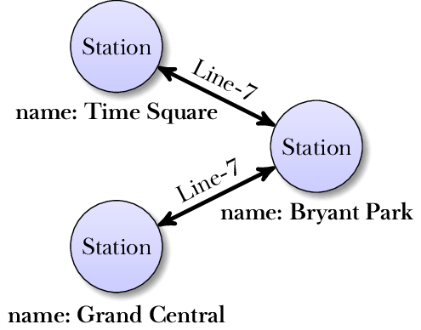

Up -understood
Figure 5.2 shows an example graph for a metro network. It represents stations of the New York City metro as nodes (hence, nodes are labeled as “Station”). Edges represent direct connections and are labeled by the associated metro line. Nodes are associated with a “name” property, assigning nodes to the name of the corresponding station.
The fact that graphs can be used to model various types of data has motivated a variety of specialized systems, called graph database systems, for graph data processing. These systems support graph-specific query languages (not SQL), enabling users to formulate complex questions about the underlying data. Graph database systems are optimized for processing large graphs efficiently.
Next, we will use language models to translate questions in natural language into queries, formulated in the graph database management system. We will see that this scenario requires only small modifications, compared to our approach for translating questions into SQL.

5.6.1 Setting up a Neo4j database

Figure 5.3 Start screen of the Neo4j sandbox. Click on the “Launch the free Sandbox” button.
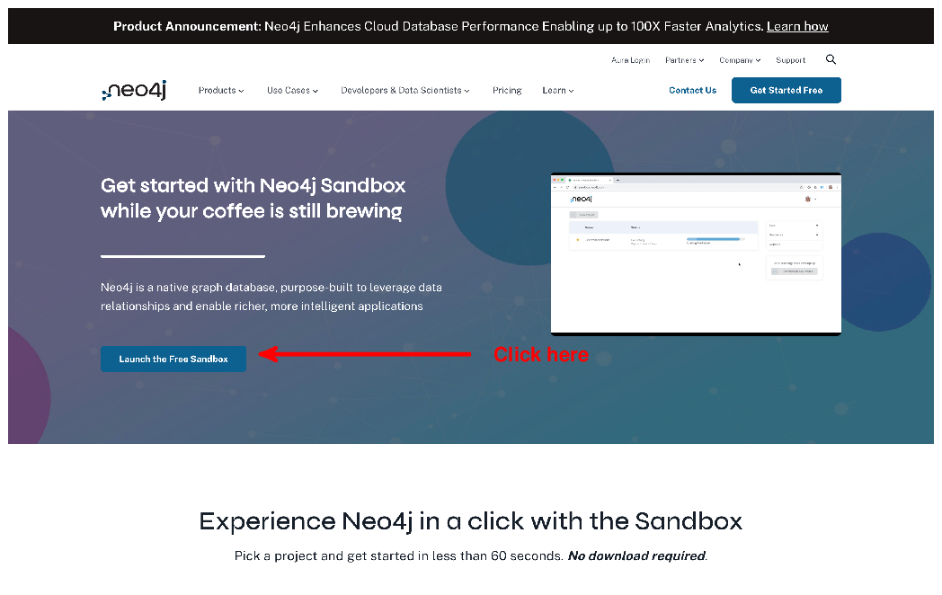

Up - Understood
We will use the Neo4j system, a database system specialized for graph data. You don’t even have to install anything on your local machine. Neo4j comes with an online demo that we will use next. First of all, go to https://neo4j.com/sandbox/ in your Web browser. You should see the screen depicted in Figure 5.3. Click on the button below to start the sandbox. This should open a login form, in which you can decide to create a new account or use existing accounts (e.g., a Google account).

Figure 5.4 Select the movies database and click on “Create” to create a corresponding instance.
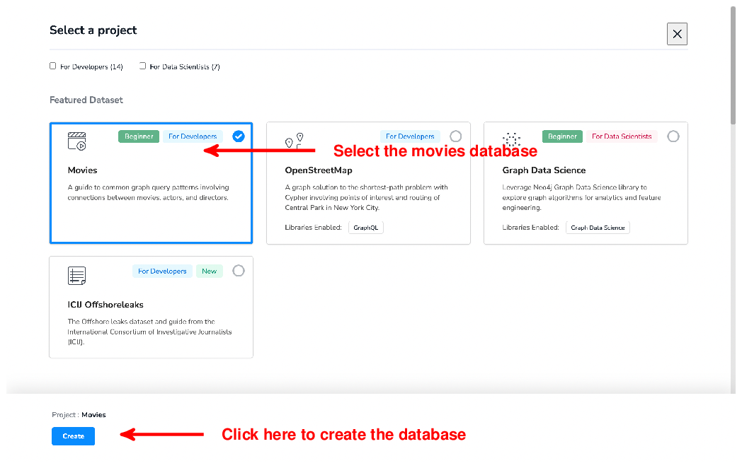

Up - understood
Figure 5.4 shows the screen you should see next. Here, we can select one out of several example databases to try out Neo4j. We will be using the “Movies” database. This database contains information on movies and actors who played in them (representing movies and actors as nodes). Click on the Movies database and then on the “Create” button below. This will create an instance of the database and prepare it for querying. Creating the database may take a few minutes. Afterward, you will be able to open the Movies database and access the query interface.

Figure 5.5 Click on the database icon (left upper corner) to access information about the current graph database, including the types of nodes and edges.
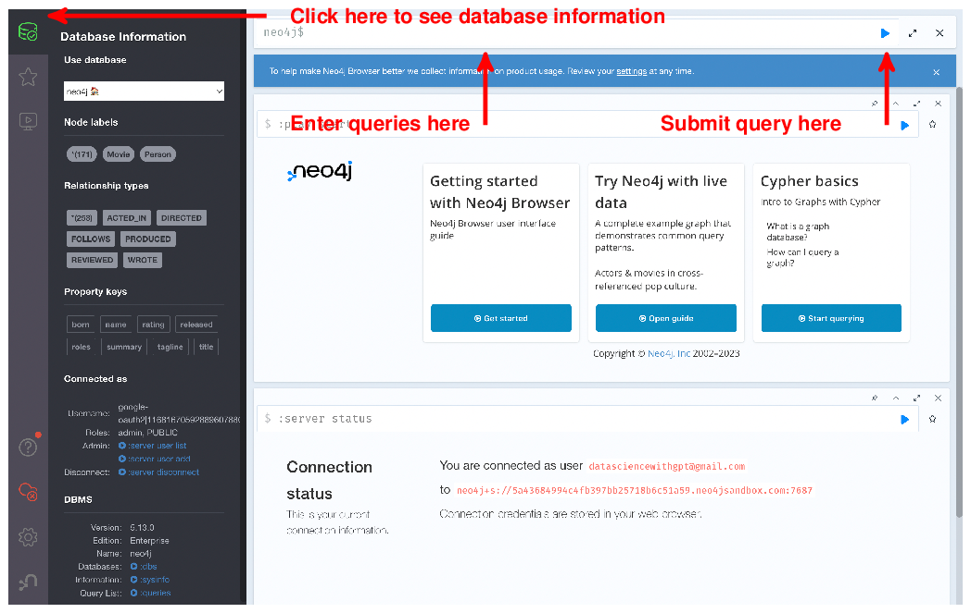
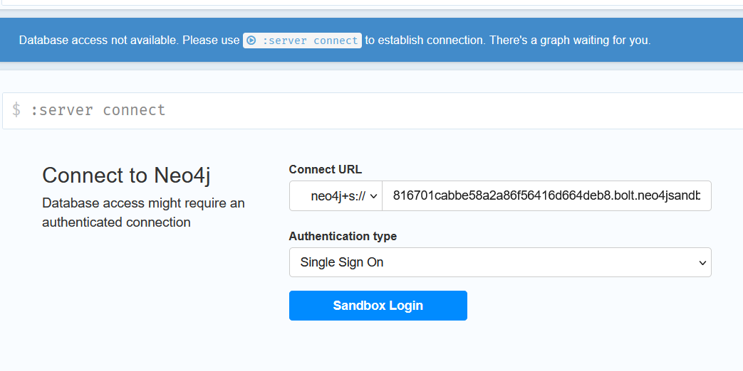

Up – understood.
Figure 5.5 shows the query interface of Neo4j. First of all, click on the database icon on the left upper corner to see an overview of the database. The database contains multiple types of labels (i.e., node types), including People and Movies. Also, it contains relationship types such as ACTED_IN and DIRECTED, labeling the edges in our graph. For instance, the two aforementioned relationship types allow us to keep track of who played in which movie (ACTED_IN) and who directed which movie (DIRECTED). Properties are associated with nodes and assign keys to values. The database overview reports on property keys such as name (assigning an actor to a name) and title (assigning movies to titles). You can enter queries in the text box at the top of the screen and submit them by clicking on the button to the right of the text box.

5.6.2 The Cypher query language
Neo4j supports the Cypher query language. While a full introduction to Cypher is beyond the scope of this book (have a look at the Neo4j documentation instead), we will quickly go over the basics. The purpose of this introduction is merely to be able to understand, at a high level of abstraction, the semantics of the queries generated by the language model.
A simple type of Cypher query uses a match statement, describing a sub-graph to find. For instance, we might simply want to find all nodes of a certain type. The query for finding all persons in our Movies database is the following:
MATCH (p:Person) RETURN p.name
copy
The MATCH statement describes a pattern to match. In this case, that pattern consists of single nodes of type “Person”. The MATCH statement assigns nodes or edges that appear within the pattern to variables. In this case, we introduce variable p and assign it to nodes matching the pattern. The RETURN statement describes the query result, based on matched patterns. Here, we instruct the system to return the name property for each node matching the pattern.
Patterns can be more complex than a single node. For instance, we might want to find the titles of all movies starring the actor Tom Cruise. In this case, the pattern we are looking for consists not of a single node but of two connected nodes. We are searching for a node of type Movie, connected via an edge of type ACTED_IN to a node of type Person whose name property is set to “Tom Cruise”. This can be accomplished by the following Cypher query:
MATCH (p:Person {name: 'Tom Cruise'})-[:ACTED_IN]->(m:Movie)
RETURN m.title
copy
The expression (p:Person {name: 'Tom Cruise'}) matches all nodes of type Person whose name property is set to “Tom Cruise”. Similarly, the expression (m:Movie) matches all nodes of type Movie. Finally, we connect those two by the expression -[:ACTED_IN]->. This expression represents a directed connection (hence the arrow shape) between the first node (representing Tom Cruise) and the second node (representing an arbitrary movie). The type of the connection is restricted to ACTED_IN (excluding, for instance, movies directed by Tom Cruise in which he did not act). Finally, note that the MATCH expression assigns parts of this pattern to variables again. Tom Cruise will be represented by variable p and the movies in which he played will be represented by variable m. The RETURN expression retrieves the title property of the movie node.
Finally, let’s see how Neo4j can calculate aggregates (similar to SQL):
MATCH (p:Person {name: 'Tom Cruise'})-[:ACTED_IN]->(m:Movie)
RETURN count(*)
copy
This query is quite similar to the one before and simply counts the number of movies featuring Tom Cruise as an actor. The RETURN statement is here replaced by a corresponding aggregate. If you enter the query correctly, you should obtain “3” as the query result (which tells you that the example database is incomplete).
Any comments on section 5.6 Graph data?

? – account setup was a little confusing and I was required to create a free account, in addition to a sandbox account. After setup, sample queries ran without issue.

5.7 Querying graphs in natural language
Instead of learning the Cypher query language, let’s see whether our language model can help with translating our questions into queries.

5.7.1 Overview
We will use a similar approach as we used for translating questions to SQL queries. The only thing we need to change is the prompt to our language model. Instead of instructing the language model to translate to SQL, we instruct it to translate to Cypher. Fortunately, language models like GPT have seen significant amounts of data during pre-training. As we will see in the remainder of this section, this pre-training data must have included Cypher queries as well and that’s why we can use language models for translation. As always, there are no absolute guarantees, and Cypher queries generated by the language model may not accurately translate our questions. However, at least for simple queries, the translation is typically correct and can help us when learning the Cypher query language ourselves.
To translate questions into Cypher queries, we need to include several pieces of information in the prompt. First of all, this includes the question that we want to translate. Second, this must include a description of the database structure. In the case of SQL, the database structure is defined by tables and column names. In the case of a Neo4j database, we want to include information on available node and edge types, as well as the names of the most relevant property keys. This is, essentially, the information shown on the left side of Figure 5.5.
Listing 5.5 shows an example prompt, instructing the language model to translate the question “How many movies are stored?” to a Cypher query on the Movies database. The prompt starts with a description of the database, including node labels, relationship types, and property keys. Then, it provides the question that we want to translate, along with a hint about the target query language (Cypher).

Listing 5.5 Example prompt for text-to-Cypher translation.
Neo4j Database:
Node labels: Movie, Person
Relationship types: Acted_In, Directed,
Follows, Produced, Reviewed, Wrote
Property keys: born, name, rating, released
roles, summary, tagline, title
How many movies are stored?
Cypher Query:
copy
Using a language model such as GPT-4o, the prompt should lead to an accurate Cypher query like the one below:
MATCH (m:Movie)
RETURN COUNT(m) AS numberOfMovies
copy

Up - understood
You can enter this query in Cypher’s query interface and should receive the correct result of 38.
The code discussed next translates questions into Cypher queries, using prompts of the structure above. As we have already seen an end-to-end natural language query interface, we content ourselves with a simple text-to-Cypher translator. The goal here is to demonstrate the versatility of language models. After reading this chapter, you should be able to easily develop natural language query interfaces, based on language models, for all kinds of tools for structured data processing.

5.7.2 Code discussion

Listing 5.6 Translating text questions into Cypher queries for Neo4j.
import argparse
import openai
import re
import time

client = openai.OpenAI()

def create_prompt(question):
""" Generate prompt to translate a question into Cypher query.

Args:
question: question about data in natural language.

Returns:
prompt for question translation.
"""
parts = []
parts += ['Neo4j Database:']
parts += ['Node labels: Movie, Person']
parts += ['Relationship types: ACTED_IN, DIRECTED,']
parts += ['FOLLOWS, PRODUCED, REVIEWED, WROTE']
parts += ['Property keys: born, name, rating, released']
parts += ['roles, summary, tagline, title']
parts += [question]
parts += ['Cypher Query:']
return '\textbackslash{}n'.join(parts)

def call_llm(prompt):
""" Query large language model and return answer.

Args:
prompt: input prompt for language model.

Returns:
Answer by language model.
"""
for nr_retries in range(1, 4):
try:
response = client.chat.completions.create(
model='gpt-4o',
messages=[
{'role':'user', 'content':prompt}
]
)
return response.choices[0].message.content
except:
time.sleep(nr_retries * 2)
raise Exception('Cannot query OpenAI model!')

if __name__ == '__main__':

parser = argparse.ArgumentParser()
parser.add_argument('question', type=str, help='A question about movies')
args = parser.parse_args()

prompt = create_prompt(args.question)
answer = call_llm(prompt)

query = re.findall('```cypher(.*)```', answer, re.DOTALL)[0]

print(f'Cyper Query: {query}')
copy

Up – understood.
Listing 5.6 shows code for a text-to-Cypher translator. The tool is used over the command line, using the same input format as Listing 5.1. The question to provide is given as an input parameter. Given that, the code generates prompts of the aforementioned structure, sends them to the language model, and returns the result (hopefully a correct Cypher query) to the user.
The primary change, compared to Listing 5.1, is the function for generating prompts . Here, the function generates prompts instructing the language model to translate questions to Cypher queries. Note that the Neo4j database structure is hard-coded. Similarly to before, a more sophisticated version of this interface could extract the database structure automatically from a corresponding database reference. Finally, we extract the Cypher query from the raw answer of the language model , using a similar regular expression as before.
Any comments on section 5.7 Querying graphs in natural language?

Up – Good explanation. Code executed as described.

5.8 Summary
- Structured data follows a standard format, making it easier to parse
- Examples of structured data include tabular data and graphs
- Structured data is often processed via specialized tools
- E.g., relational database systems process tabular data
- Tools for data processing often support specialized query languages
- Language models translate natural language to many formal query languages
- Prompts must contain the question and a description of the database
- Different types of data require a different description structure
- Sending such prompts to the language model results in formal queries
- Do not trust language models to produce correct queries in each single case
What did you think of this chapter?
hide feedback

1
How many stars would you give this chapter?

4

2
What is your overall impression of this chapter?

Good explanations of interfacing to ChatAPI to create SQL and Graph queries, and interfacing to SQL data base. Could be helped with diagrams showing the flow of data and processing. More details needed for Neo setup.

